# TECH QUIZINE- EVENT REPORT

## Summary

ACM, GITAM had conducted the "TECH QUIZINE" event. This is the first event for the academic year 2021-22 by ACM, GITAM. This quiz competition was highly endorsed and during this digital period, spending time by playing fun and informative quiz on various computer science and technology domains in addition to Verbal and Aptitude skills here at GITAM, Visakhapatnam. The event was organized on 19/08/2021 from 11:00 AM to 12:00 on Kahoot, and the participants interacted with the core team through the Zoom platform.

The publicity and registrations for the event started three days before the event, and students were sent the event's details through the club's official mail id. A WhatsApp message was also circulated briefing about the event, and all the details of the event were mentioned there. The posters and videos regarding the event were shared on various social media handles such as Instagram and LinkedIn. 169 participants attempted the quiz.

By the end of the event, all the attendees learned about some concepts related to computer science and programming domains, including the execution of the programs, concepts regarding Programming languages, Computer Networks and Operating Systems, and questions relating to Verbal and Aptitude skills. Attendees appreciated the event, and the event was a great success. The attendees were asked to fill in their details, and the top three scores on the Kahoot quiz podium were given promised prizes by ACM, GITAM.

## Photographs

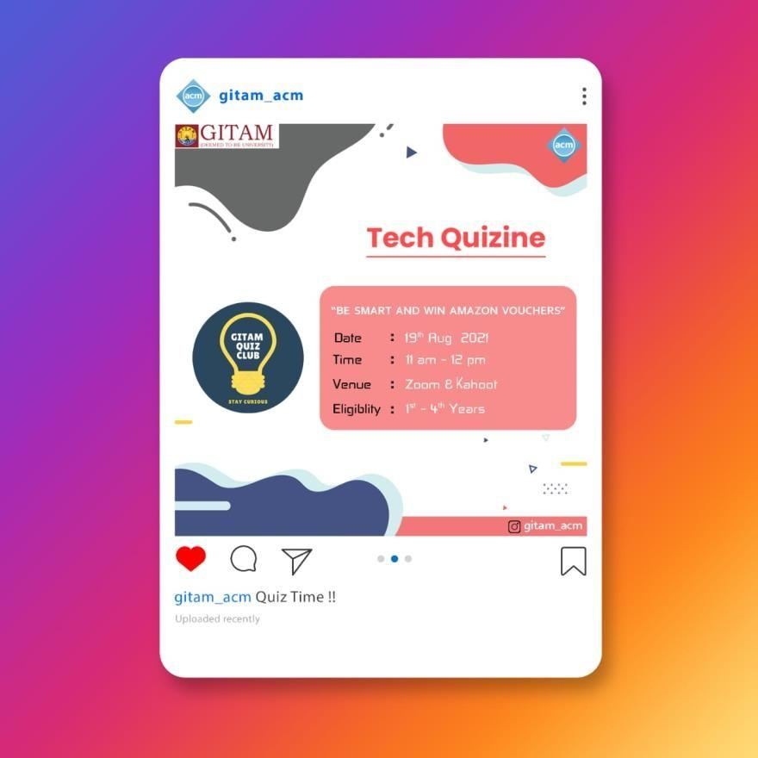

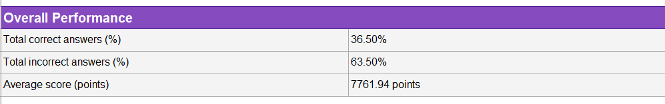

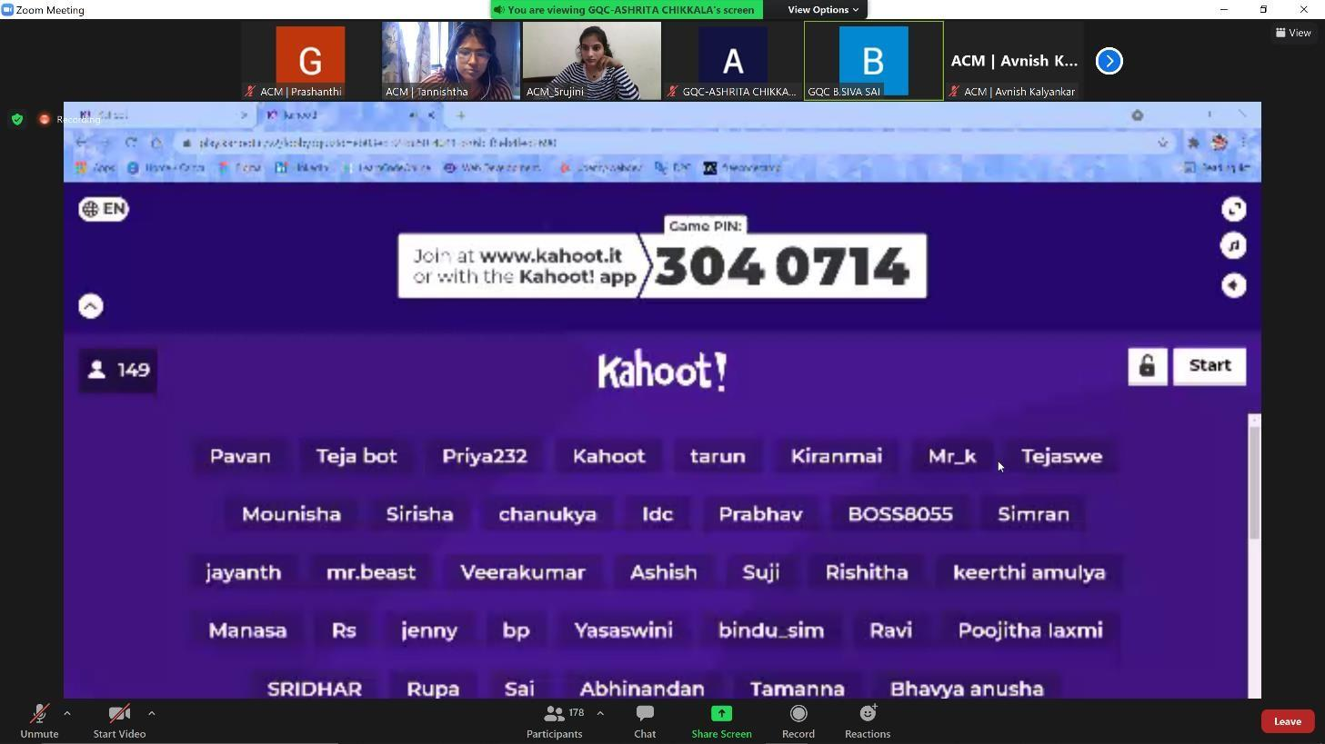

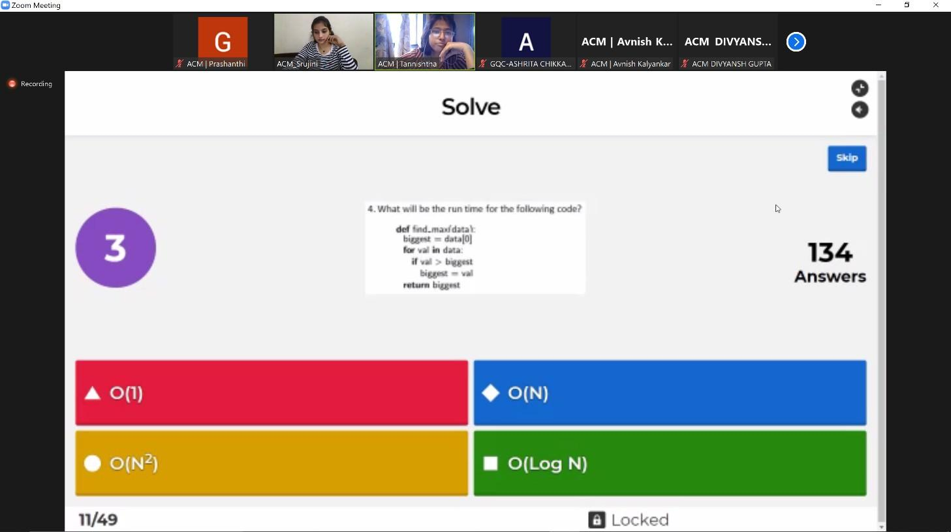

Event Snapshot

| **EVENT SNAPSHOT** | |
| --- | --- |
| Event Name: | Tech Quizine |
| Organizing Club: | ACM |
| Event Date: | 19/08/2021 |
| Event Time: | 11:00 AM to 12:00 PM |
| Event Mode / Venue: | Online / Zoom and Kahoot |
| Social media reach: | Instagram: @gitam_acm  LinkedIn: https://[www.linkedin.com/company/acm](http://www.linkedin.com/company/acm)  -gitam-association-for-computing- machinery/mycompany/ |
| Registrations: | 322 |
| Number of Participants/Attendees: | 178 |
| Winners (if any): Name - Regd ID - Email ID | 1st prize: Manishankar – 121810314023 –  [121810314023@gitam.in](mailto:121810314023@gitam.in)  2nd prize: Likitha – 121910319014 –  [121910308014@gitam.in](mailto:121910308014@gitam.in)  3rd prize: Nandini – 121910308009 –  [121910308009@gitam.in](mailto:121910308009@gitam.in) |
| Faculty - Judge - Guest Speaker: | NA |
| Event Report Author - Designation: | Prashanthi - Event Management Lead, ACM, Gitam.  Snehita - Membership Chairperson, ACM, Gitam. |